 | Departamentul Automatică şi Informatică Industrială  Facultatea Automatică şi Calculatoare  Universitatea Nationala de Stiinta si Tehnologie  POLITEHNICA din Bucureşti  Splaiul Independenţei 313, 060042, Bucureşti, România  Sala ED 412, Tel. 021/402.92.69  www.aii.pub.ro, email: secretariat.aii@upb.ro | 

Sesiunea de Comunicări Şiinţifice Studenţeşti
Ediţia 2024

Modelare si suport software integrat pentru restrictiile in vigoare privind accesul
auto in centrul oraselor din Europa

Autor: Andrei SĂRĂNDAN, Licenţǎ – Anul 4, Grupa 341 A1, Facultatea de Automatica şi Calculatoare
Adresa e-mail: andreisarandan02@gmail.com
Îndrumător ştiinţific: prof.dr.ing. Anca Daniela IONITA
Contents
1. Introduction 3
2. Inclusion of the study's domain of interest 4
3 Thesis Statement 5
4. Application Development 7
4.1 Backend Development 7
4.1.1 Foundations 7
4.1.2 Route handling in Flask 7
4.1.3 Database 8
4.1.4 Access validation algorithms 10
4.2 Frontend Development 11
5 Application usage 13
6. Conclusions and Future Plans 14
Bibliography 15

1. Introduction
The World Wide Web represents without a question an indispensable tool in the daily life during present times. Its presence can be seen everywhere around us, from communication and entertainment to most jobs migrating on computer or desk office based on internet. On the other hand, the escalating threat of global warming is more evident than ever before, with recent events occurring across the globe. If more efforts were made to use the internet capabilities to diminish the pollution, the world would become a better place for future generations.
The scope of this project is to present a web-based application that helps users comply to traffic regulations mandated by The European Union, primarily focusing on Low Emission Zones (LEZs). This web application seeks to raise awareness and trust in this scope, enabling users to make informed planning and consider the environmental impact of their travel and vehicle choice. It represents more than just a text repository or a presentation website as it is a comprehensive platform, which includes modern technologies like Application Programming Interfaces (APIs), extensive database model and complex access validation algorithms. All of these aim to deliver a great user experience, from account creation processes, thus raising the possibility of personal vehicle registration, to trip planning features. To improve the user experience, all the complex logic methods, data sets and algorithms are hidden behind the friendly and interactive interface.
The creation of this web application was done in three main steps. Firstly, the application development was based on a tight connection between backend and frontend parts, involving different programming languages and frameworks. Secondly, the extensive relational database model was designed to store relevant information about both the Low Emission Zones and application users. Lastly, in creating the database, a prolongated research was needed to cover the different complexities of the hundreds of LEZs throughout Europe. A key factor was to also fit the everchanging character of the LEZs. The information presented on the web application must be correct, up-to-date, and presented in an understandable manner. By doing so, the web application aims to contribute to broader efforts to create a more sustainable and resilient future for all.

2. Inclusion of the study's domain of interest
The increasing concerns regarding pollution necessitate the implementation of various measures aimed at enhancing air quality. Pollution, resulting from a multitude of sources and presenting in various forms, possesses significant threats to both human health and the environment. Among them, vehicular emissions stand out as one of the most prominent forms of pollution. This is mostly concerning in the urban settlements and metropolises that are suffocated by the raising number of cars, with an average of nearly one car per 1-2 individuals. Passenger cars stand out as a major polluter, accounting for 61% of total CO2 emissions from EU road transport [1].
The European Union is striving to drastically reduce air pollution by implementing new legislation aimed at pushing new vehicles towards achieving zero CO2 emissions. However, the actual progress has proven to be much slower than we have hoped.
The primary methods of reducing CO2 emissions from vehicles are manufacturing more efficient cars and changing the fuel type by transitioning to more eco-friendly ones, ideally derived from green or regenerative energy [1]. Even though electric and hybrid cars are taking a considerable part of the newly registered vehicles, the issue of older, higher-emission vehicles must not be overlooked.
Designing a schema to reduce the pollution proves to be a challenging, yet necessary aspect. Such schemas, referred as Urban Vehicle Access Regulations [2], have been implemented in many West European cities. These rules are found in different forms such as low emission zones, zero emission zones, tolls for driving in congested areas, creating more space for pedestrians, changing parking rules, and limiting traffic in certain areas. The goal is to comply with the newly adopted air quality standards, while also improving traffic.
Generally, vehicle categorization and access are based on the vehicle type, fuel type and emission class (Euro emission standard). Additionally, such regulations usually impose some form of toll or fee that must be paid in order to gain access into a specific zone. Out of the many existing forms of Urban Vehicle Access Regulations, most of them are Low Emission Zones (LEZs), accounting for 73% of the current regulations [2].
Low Emission Zones (LEZs) are geographical areas, usually located in large urban settlements, where specific restrictions are imposed on more polluting vehicles. Typically, this kind of vehicles are prohibited from entering the zone, although in certain instances, a fee can be paid for access. Low Emission zones have proved to be a great method of reducing air pollution, especially targeting fine particles such as NO2, which are highly correlated to several respiratory diseases.
The European Union proposes a strategy to gradually implement such areas in the following years [4]. This approach facilitates the acceptance and adoption of a Low Emission Zone and allows each nation to fine-tune the schemas to better fit the needs and possibilities of the country and its citizens. Local authorities can effectively manage the requirements and priorities, enhancing the efforts to minimize pollution as much as possible.
According to the report made by statista.com [9], forecasts expect a significant expansion of Low Emission Zones (LEZs) throughout Europe. Projections indicate a substantial increase in the number of LEZs, with an estimated total of 510 zones across 17 countries. This increase highlights the European Union's commitment to mitigating air pollution and promoting sustainable urban development throughout the continent.

3 Thesis Statement
The scope of this research revolves around the development of an application geared towards improving user experience in navigating Low Emission Zones (LEZs), with a focus on algorithms for validating vehicle access within LEZ cities. Since this concept is very new and still under development, the main scope is to raise awareness and promote their acceptance. LEZs may pose complexities for many individuals, hence efforts are needed to simplify comprehension and facilitate access.
The aim is to create an intuitive web application that provides information and help to access these Low Emission Zones throughout Europe. Since this is an ever-changing topic, the database system is incorporated to cover the regulations that are effective in July 2024. It is designed so that it can be adapted to ongoing updates, in order to provide valid information to the end-user.
While online resources and information are indeed available, usually the information is dispersed across many different platforms, with segmentation made by countries or even by cities. Fragmented information can be overwhelming for regular users, who would often find themselves spending significant time navigating through multiple websites when gathering relevant information for their specific situation and needs.
The development of a new web-based application arises from the identification of a specific niche within the market, tailored for to the needs of regular individuals. The goal of creating the app is to eliminate all barriers of entry, such as subscription fees or even prior expertise in the domain, in order to democratize access to information about Low Emission Zones. This will empower a wider audience to make informed decisions before buying a new vehicle, while also expanding the impact and reach of LEZs.
One of the key aspects of this app is the emphasis on tailored solutions, allowing users to create accounts and customize their experience according to their needs. The platform allows users to save vehicles to their account and make use of the route planner features in order to facilitate navigation across European LEZs. This approach enhances user engagement and ensures that individuals can access relevant information tailored to their specific needs.
In line with the user-centric design, the app adopts a guided interface, streamlining the user experience while also reducing the time required to obtain relevant information for the situation at hand. The intuitive design allows users to quickly obtain the information they require without navigating through extensive pages of content. Over more, the app features informative text-based pages, for comprehensive insights into LEZs.
At the core, the application makes use of a robust database and extensive algorithms for assigning the correct registration to a vehicle and LEZ access validation. These technical features ensure the accuracy, reliability, timeliness, and relevance of the provided information, in order to ensure confidence in users and promote compliance to LEZs regulations. While the app is designed to be oriented towards individual consumers, the database model and it’s free-to-use nature are also well-suited for enterprises, accommodating a larger number of scenarios, vehicles and routes within the same or different accounts.

4. Application Development

4.1 Backend Development

4.1.1 Foundations
Backend development represents the backbone of web applications architecture and it can be considered the engine that powers the entire system. It is responsible for a range of critical activities, like logic implementation, data processing, and handling communication with the user interface. A robust backend is essential for applications intended to fulfil a large purpose, empowering them to manage data effectively and to interact with users. Without the complex backend, web applications are essentially limited to static website pages, without the dynamic functionalities available in most modern digital experiences.
In the context of this application, the backend architecture carries a crucial importance, as it is responsible for handling data management, LEZ access validation through algorithms, user account creation, HTML requests and responses. One of the key aspects of the backend architecture in a web application is the establishment of routes, which essentially serve as pathways for directing incoming web requests to the appropriate resources within the application. Managing a meticulous route configuration, ensures smooth user interaction and navigation within the web application.

4.1.2 Route handling in Flask
Route handling represents a fundamental aspect of web backend development, as it is responsible for dictating how URLs are mapped to specific functions within the application. Considering that Flask is the main framework used in the development of this application, this mapping enables the execution of specific code sequences when a user accesses a particular endpoint.
In Flask, routes are generally defined using Python functions which are decorated with a specific syntax, that includes the web application instance [6]. The python function decorated by this operator is responsible for handling the request when users navigate to the specified page. Additionally, the decorator accepts the “methods” parameter, which refers to the HTTP requests accepted by the configured route, such as “GET” and “POST”.

4.1.3 Database
At the core of this web application is the relational database model displayed in figure 1. This application uses SQLAlchemy, an Object-Relational Mapping (ORM) library which allows developers to define database tables using Python classes. The database is created and managed in the models.py file.
Structurally, the Zone table is responsible for storing the main information for the Low Emission Zones. This represents key information regarding vehicle access, such as required registrations or minimum European emission standards. This data is accessed by internal algorithms and usually queried by class functions that are also defined in the models.py file.
ZoneTemporaryData table is related to Zone table through a foreign key. Specifically, ‘zone.id’ column from ZoneTemporaryData references the primary key, ‘id’, from Zone table. This means that each instance from ZoneTemporaryData belongs to a single instance in Zone table. As its name suggests, ZoneTemporaryData table is designed to hold data regarding the temporary characteristics of some Low Emission Zones. This is especially relevant for countries like Italy or Bulgaria which have Winter Low Emission Zone schemas.
Another essential part of the database model is the User table and the ones related to it. The User table is created to store the essential information for account creation. The amount of information is minimal, as the nature of the application does not require more, but this is also favourable for safety and resource storage reasons. The main fields, email and password are need for user login. In order to keep the same standards as most modern applications, the database stores a hashed version of the password. The encryption is made using the SHA256 algorithm, which is one of the most secure and used hashing algorithms today [31].
As both names suggest, Car and SavedRoute tables store the relevant data for the user’s account. They are related to the User table through a foreign key, which creates a one-to-many relationship. This means that a user can have multiple car instances or saved routes associated with his id. While in reality a vehicle has plenty of details, the application is designed to store only the data relevant to validating the access in the already existing LEZs. The completion of this data is the user’s responsibility and he should respect the information registered in the vehicle book.
Over more, for each country that has a Low Emission Zone, a class extends GeneralRegistrations class. The latter is an abstract class and serves as a blueprint for the other country-based registrations, as it does not create a table in the database.

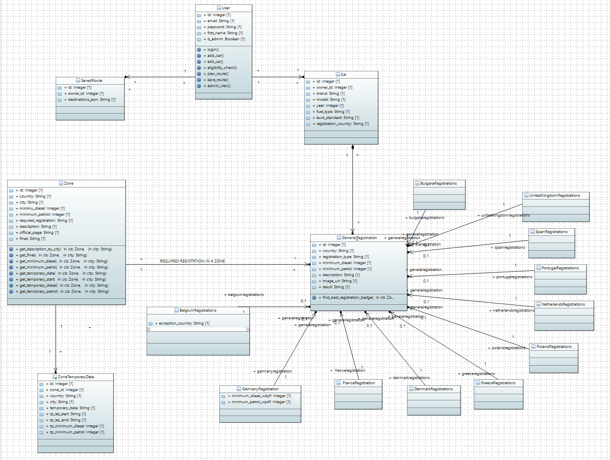
Figure 1 Database model

4.1.4 Access validation algorithms
The system encompasses a different algorithm for each country that has a LEZ schema. This strategy is necessary for covering all possible scenarios while assuring the validation of the relevant criteria.
The structure is designed to ensure an easy upgrading (more countries, more vehicles etc). the scalability of the application. This is ideal because of the evolving nature of the Low Emission Zones. In order for the application to stay relevant in the future, slight adjustments might be needed in the access validation algorithms. Separating the algorithms for each country means the backend can be viewed as a set of interchangeable modules. Each module represents a country that has a Low Emission Zone schema and is structured in three parts: the validation algorithm, registrations/minimum requirements for access and the country objects.
Since each Nation evolves at its own pace, this modular approach means an easier maintenance for both the developer and the stakeholders and therefore, deploying the updates for the new validation methods becomes much simpler. While the responsible stakeholders can monitor the evolution of each country separately, the developer can create small updates only in the specific module. Separating the modules and making the modifications only in one of them ensures minimum down-time of the application and quick bug-fixes.
The validation algorithms are used in the Route Planner page in order to display a short summary of the relevant information. The displayed information includes a concise statement regarding the access in the selected LEZs and other key details, facilitating user compliance to the regulations. This way, the user does not need personally research all the regulatory requirements when planning a trip. The user only needs to fill in all points of interest and select one of the previously saved vehicles.
By the click of the button, the POST request is sent to the application backend and the relevant algorithms are triggered. For each country listed in the request, the corresponding algorithm is triggered. Since most countries have different restrictions from one zone to another, the algorithms are designed to check for the city received in the request. Running a separate algorithm for each country, proves effective in handling all the possible scenarios (LEZ access granted or forbidden, LEZ not active/inactive during selected travel period, city or country does not have LEZ, etc.). This is highly challenging when checking the access for several points of interest at the same time, as this involves verifying different attributes of the selected vehicle.
While the front-end interface the Route Planner page from seems simple, the database queries, the POST request and the validation algorithms are all processed behind the scenes, in the application backend. As soon as the POST request is received, the “navigation” function handles the data inside the request. Since one request can include several points of interest, they are stored in JSON format and loaded in a list variable. By parsing this list, we can call the correct access validation algorithm for each item.
Based on the values returned by the access validation algorithms, we can create the type and the information of the notifications that will be displayed to the user. The type of the notifications is success or error and creates a suggestive design of the notifications and will be described in the Front-End chapter. The text inside of the notifications is queried from the Zone database through a series of class methods. These methods are created inside models.py file and take the city name parameter. Each of them, is responsible for retrieving key information for the user, like short description of the LEZ, penalties for not complying, official authority’s webpage, etc.
All this data is stored again in the JSON format and is sent as a response to the front-end of the application. There unpacking of the information takes place and it’s displayed to the user. This instant communication between the front-end and the back end create a user-friendly page, using the abstraction principle, meaning the complex logic of the application is hidden from the user, who is only interacting with the system through the graphic interface.

4.2 Frontend Development
At core, the web application consists of a multitude of HTML, CSS and JavaScript files, structurally tied between them. This flask application stores these HTML files inside the “templates” folder. While the CSS and JavaScript files are stored inside the “static”. This file structure is intended to create order and well organization for the developers. The application also uses Jinja templating across all web pages, as they are created as an extension of base.html file.
The navigation bar represents a key element in any web application because it assures smooth navigation across the website. Since this element is present on all webpages, the navbar was created in the base.html file.
While Google provides a wide range of options, Maps JavaScript API fits perfectly to the requirements of this web application. The API allows creation and web integration of custom, dynamic and interactive maps. All the available Low Emission Zones can be dynamically displayed right from the database.
Further the Route Planner page uses Maps and Geocoding API to display the best route. The map element is updated in real time, without the need to open a new session or refreshing the page. This is achieved by calculating the directions through a JavaScript function using the navigation feature of the Google API. This JavaScript function is called inside the asynchronous function responsible for handling the form submission. When the user clicks the “Calculate directions” button, the POST request containing the HTML form data is submitted.
Asynchronous programming is a key feature of JavaScript and is usually done by creating asynchronous functions, which use the await key word structures to suspend execution until specified conditions are fulfilled. This behaviour is called promise-based, because async functions return Promise objects. Based on their value, conditional programming is executed with structures like try-catch.
Through the async function, the system gathers the user-filled information, and creates the FormData element, which composes the body of the POST request sent to the application backend. Then, the front-end interface waits for a response from the backend algorithms. The execution is suspended using the await key word and continues after the response from the backend is received, based on which notifications are created and displayed.
While granting users freedom to navigate the application autonomously is favourable, guidance in certain selections ensures prevention of errors. This precaution is crucial and imperative for validation algorithms to receive accurate input to function optimally.
The application uses dynamic forms based on select fields that are populated or displayed conditionally. Implementing such constraints helps prevent illogical scenarios, such as saving vehicles, which not only lack practicality but also risk raising errors during the validation process.
Another way the application guides user interaction is through autocomplete functionality facilitated by the Places API by Google. The feature is designed for locations prediction, significantly enhancing efficiency by suggesting places and minimizing typing time. Its versatility includes various points of interest, including cities, streets, hotels, and more. The use of autocomplete function ensures the validity of selected places, guaranteeing precise input for the Google Geocoding API.
The restrictions are not implemented to hinder user access. Rather, they are designed to ensure system functionality and enhance user experience, ensure accurate data input and minimize errors.

5 Application usage
Users benefit of the application features after the registration process. Creating an account, unlocks the full potential of the application. User do not need to enter any personal information, because the accounts are needed to unlock database access. This means, users can associate multiple vehicles to their account but also save their frequent or favourite route.
Registering a vehicle is the first step after account creation. Here, users can fill in the fields relevant for LEZ access validation, like fuel type or European emission standards or even add registrations already assigned to their vehicle. Later, they have the possibility to edit any of this features, to correct potential mistakes or to assign newly obtained registrations. In filling this information, users have very few restrictions which are meant to help them fill in correct data, but the responsibility lies on their shoulders to insert the correct information from the vehicle registration book.
After registering the vehicle in the application database, the user can use the Eligibility Check page to test the car for potential registrations. This page is meant to tell the user which registrations are correct for his vehicle. The feature is especially helpful for countries like France, which have a multitude of registrations available. All countries are available for this so users can test their vehicles against the regulations in any European country that has some form of LEZ.
This feature is especially helpful in combination with the Route Planner page. As the name suggests, it was designed to help users plan their trips thought Europe. First the user should again select one of the vehicles saved to his account and then insert all the destinations he plans to visit. This is important, since LEZs primarily affect city centres, which are generally avoided by the navigation systems, the validation algorithms only apply to the cities filled in by the users. With the hep of Google Places Autocomplete, users can select any point of interest and the city and country are automatically determined. Therefore, they do not need to directly specify those.
The access validation algorithms test the selected vehicle against the regulations imposed by the selected cities. In no time, users will get all the information relevant to their route. For each city, a short notification pops up, informing the user about whether or not LEZ is imposed, what are the minimum European emission standards or registration requirements and which are the possible penalties. Also, the user is prompted the links relevant for more information on the respective LEZs. First, he can access the country info pages on this application and also the official LEZ page on local authorities’ website. The country info pages, respond to some of the frequently asked questions about the LEZs, like which cities have LEZ in a country, whether a sticker or registration is required, what are the penalties, etc. Mainly, this information can be easily accessed through the Eligibility Check and the Route Planner pages, which have an interactive nature, but are also displayed, as static informational, yet well-structured text.
Having all the information in one place, is a unique element of the application and should help users comply to the regulations imposed, helping themselves but also the rest of the population.
The application is in fact a complex access validation system and was designed to integrate a seamless transition between its component elements. Combining the pages described above, the user can first select his vehicle, which he can test for eligible registrations and city LEZ access. Further, the user is guided to obtain the registrations necessary, if compliant, in order to obtain access in the LEZs selected in the Route Planner page.

6. Conclusions and Future Plans
The application successfully represents an online platform that facilitates users' access to information regarding Low Emission Zones (LEZs) across Europe. Its user-friendly interface and intuitive features contribute to an engaging experience and reduce the barrier of entry in this field. On the other hand, functionalities, such as account creation and car saving, foster client loyalty and trust, thereby enhancing user retention and satisfaction. This lays a solid foundation and ensures a positive user experience, as individuals can quickly search accurate information based on their specific circumstances.
It is exclusively designed for passenger car drivers. However, a future expansion can encompass all vehicle types, from motorcycles to heavy vehicles. This strategic plan not only broadens the application's user base, but also creates possible collaborations with enterprises for managing fleets of cars. This can be easily achieved by continuing the research the same way it has been done so far and extending the database model and validation algorithms.
Furthermore, the integration of a shop feature would enable users to directly purchase registrations through the application. This additional function not only enhances user convenience but also diversifies revenue streams, thus increasing the application's sustainability.
Crucially, ongoing updates are imperative to ensure the application remains aligned with the ever-evolving landscape of LEZs across Europe and adapts to regulatory changes. Maintaining up-to-date information is imperative to the application's effectiveness. There is also potential of covering other urban regulations, such as Zero-Emission Zones or road tolls, further enhancing the application's utility and relevance in addressing contemporary mobility challenges.

Bibliography
[1] https://www.europarl.europa.eu/topics/en/article/20190313STO31218/co2-emissions-from-cars-facts-and-figures-infographics. (n.d.).
[2] https://transport.ec.europa.eu/transport-themes/urban-transport/urban-vehicle-access-regulations_en
[4] https://www.mdpi.com/2071-1050/15/23/16260
[5] https://dieselnet.com/standards/eu/lez.php
[6] https://www.germanemissionssticker.com/the-german-diesel-ban/
[9] https://www.statista.com/statistics/1321264/low-emission-zones-europe-by-country/
[31] Permana, Iman, Mardi Hardjianto, and Kiki Ahmad Baihaqi. "Securing the website login system with the SHA256 generating method and time-based one-time password (TOTP)." Systematics 2.2 (2020): 65-71.

